Titre du projet : Archéo-sismicité de la faille Nord Anatolienne

Volet : Recherche

Porteur du projet : Julia de Sigoyer

Laboratoires impliqués : ISTerre, ENS, Archeological lab. Bursa University Tr, Kandilly geophysical observatory Tr.
Rapport intermédiaire du projet pour l’année/la période 2014/16

Bilan d’activité (1 page max)
The purpose of the AO4 OSUG@2020 project, that obtained a financial support in 2014, was to develop a new approach to study the seismotectonic behavior of active faults using archaeological, geomorphological and tectonics markers. This project has involved geologists, archaeologists, and geophysicists from France (ISTerre, ENS), and Turkey (Bursa univ and Kandilly observatory) and benefits from a full time Ph-D student (Yacine Benjelloun). Thanks to the AO4 OSUG@2020 we have found an exceptional site for our study: the city of Nicaea (present Iznik, Turkey) located on the border of the Iznik lake, 5 km north of the middle strand of the North Anatolian Fault (MNAF). This project takes place in the very exiting context of the discovery of a Roman Basilica, under the lake in 2014. The basilica has probably been destroyed and flooded during an earthquake in between 325 and 740 AD.
The aim of the project was to document, (1) the calendar of the seismicity since Antic time, (2) to localise the active faults and characterize the offset that can be observed on these fault segments, that inform on the segmentation of the fault zone, (3) to characterized the lake and land variations level and know if they can be related to tectonic subsidence.
- a) The characterization of the past seismicity in the Iznik area can be document by establishing the different phases of building in the archaeological building. We have selected critical infrastructures such as the aqueduct that is essential for the life of a city, and that is restored as soon as it was damaged. Three main stages of restoration were observed in the aqueduct. It was first build during the reign of Hadrian Ist century and restored at the time of Justinian 8th century. Around the 11th century, much of the facing of the aqueduct was rebuilt, probably after important damages. Restorations were also done in the 13th century. The repairing mortar of the building, were sampled. Charcoal founded in the mortar will be date soon to confirm the age of restoring phases.
b) The orientations of all the damages observed on archaeological buildings were measured. They show preferred NS orientation reinforcing their seismic origin (coming form the MNAF).
- The identification of active fault segments and the quantification of offsets on land has requires the mapping of fault segments. For this purpose, Pleiade images were acquired and a high-resolution Digital Elevation Model (DEM) (1,5 m horizontally) has been performed by Yacine Benjelloun during his Ph-D (Fig. 1). He has produced a detailed structural map in the Iznik area of the different fault segments. Many geomorphological markers, such as channel gullies, alluvial or lacustrine terraces and moraines, have been offset by the faults. All the offsets have been measured on the DEM and on the field (during two field missions). Thanks to the statistical treatment of these data, a characteristic offset increment of 2,5 m has been deduced along the MNAF that represents certainly the displacement recorded during each earthquake. Some geomorphological markers imprint several earthquakes and shows displacement of (nber of EQx2.5m), while other one just imprint one offset. The four last earthquakes imprinted in the landscape follow this characteristic offset. The geomorphological markers that were offset were sampled and will be dated with C¹⁴, Be¹⁰, Cl³⁶ to obtain long term slipping rate on the fault.
- Identification and quantification of lake level and ground level variations
- Rapid changes in ground elevation in the city of Iznik and lake-level variations have been observed on the northern and southern banks of the lake. These ground-level variations have strongly impact the human implantation in Iznik as revealed by the sunken buildings. These variations of ground and lake level can have different origins. They could be due to tectonic subsidence linked to with the normal component of the faults, as suggested by the tilted terraces observed on the northern banks. They could also be due to a sudden rise of lake level following a landslide eroding the outflow of the lake, or due to a period of high hydrological activity. The AO4 Osug@2020 has been used to date terraces the work is under progress. The ground-level variations in the city using archaeological data (archeomagnetism on ceramics or C14 dating on charcoal).
This project together with the INSU project we obtain (7000€) were the first step of a much bigger project. The wonderfull observations and results we obtained encourage us to apply for bigger proposal (IRS), and for two Ph D students.

Illustrations - avec légende et crédit (à envoyer également séparément)
Thanks to the pleiade images buy with the Labex AO4OSUG@2020 projet we have produce a precise tectonic map of the the Iznik area
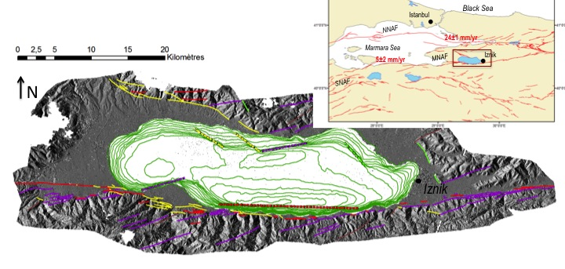
Fig. 1: Tectonic Map around Iznik Lake on the DEM acquired with pleiade images. Note the broad bathymetric curves of 5 m intervals in the lake Iznik.The faults are compatible with dextral strike slip kinematics. Principal direction of shearing (red) (-5, 5°), P-shear (-25 -5°), Riedel (5-38°), normal fault
Insert left: geodynamic context of the North Anatolian Fault. Insert right: Western termination of NAF.
NNAF Northern segment of the NAF. MNAF Middle segment. SNAF Southern segment.
VERY SMALL MAPS, HOW DEEP IS THE LAKE (GREEN LINES?)?

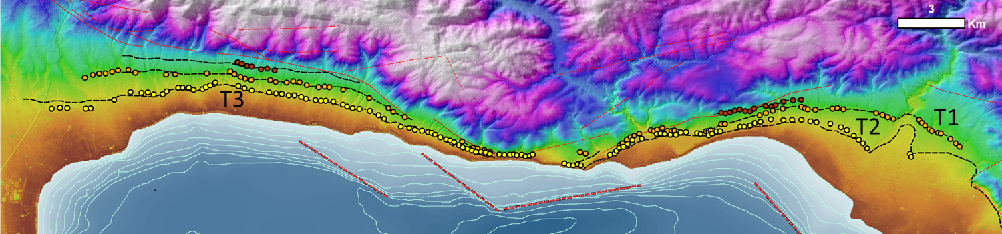

Up : Tilted lacustrine terraces on the northern bank of the Iznik lake deduced from the DEM done with the pleiade images (color represent the elevation). The tilting of the terraces may be due to the normal activity of the fault south of the lake.

Production scientifique (articles scientifiques, actes de congrès…)
- Benjelloun, Y., de Sigoyer, J., Dessales, H. (in press). Archeoseismological Investigations in the region of Iznik (Turkey). In : Iznik/Nicaea on its way to become UNESCO world heritage site. Iznik.
- Benjelloun, Y., de Sigoyer, J., Carlut, J., Hubert-Ferrari, A., Dessales, H., Pamir, H., Karabacak, V., 2015. Characterization of building materials from the aqueduct of Antioch-on-the-Orontes (Turkey). Comptes Rendus Geoscience 347, 170-180.
- Benjelloun, Y., de Sigoyer, J., Carcaillet, J., Sahin, M. (in prep) Evidence of past glaciation events between Gemlik and Mekece (NW Turkey) Quaternary Geochronology
- Benjelloun, Y., de Sigoyer, J., Dessales, H. ; Sahin, M. (in prep) Archeological study of the aqueduct of Nicaea (Iznik, NW Turkey)

Communications :
- Benjelloun, Y., de Sigoyer, J., Sahin, M., Dessales, H., Garambois, S., Carcaillet, J., Guéguen, P., 2016. La faille Nord Anatolienne dans la région d'Iznik (Turquie): évolution géomorphologique et archéosismicité. RST 2016. Caen, 24-28 octobre.
- Benjelloun, Y., de Sigoyer, J., Sahin, M., Garambois, S., Dessales, H., 2015. The North Anatolian Fault in the region of Iznik (Turkey) : Geomorphological Evolution and Archeoseismicity (poster). In : American Geophysical Union, AGU Fall Meeting 2015. San Francisco, 14-18 décembre.
- Benjelloun Y., de Sigoyer, J., Sahin, M., Dessales, H., Pizzo, A., 2015. The North Anatolian Fault in the region of Iznik (Turkey) : Geomorphological Evolution and Archeoseismicity (poster). In : MISTRALS, Conférence internationale MISTRALS, Villa Méditerranée, Marseille, 20-22 octobre.
- Benjelloun, Y., de Sigoyer, J., Dessales, H., 2015. The North Anatolian Fault in the region of Iznik (Turkey) : Geomorphological Evolution and Archaeoseismicity. In : Iznik/Nicaea on its way to become UNESCO world heritage site. Iznik, 2-4 octobre.
- Séminaire invité:
- de Sigoyer J. Lausanne Nov 2016. The North Anatolian Fault in the region of Iznik (Nicaea-Turkey): Geomorphological Evolution and Archaeoseismicity.

Bilan financier succinct (avec suivant les cas : co-financements éventuels, équipements achetés, missions, recrutements divers, fonctionnements divers…)
Afin de mener à bien cette recherche nous avons répondu à plusieurs appels d’offre car ce financement ne suffisait pas. Deux cofinancements ont été obtenus provenant de l’INSU pour ce projet. Les dates limites de ces projets se chevauchaient en partie avec le Labex A04. Nous avons visiblement confondues les dates limite des différents projets puisque le crédit qui avait la durée la plus longue a été fini avant celui qui avait la durée la plus courte….
Ces crédits ont été demandés dans le cadre du soutient de la thèse de Yacine Benjelloun qui n’a pas encore fini son doctorat. Il y a encore de nombreuses analyses en cours pour finaliser son doctorat.
Ce projet s’est initié avec le labex, nous avons obtenu des premiers résultats exceptionnels. Ce projet extrêmement prometteur entre dans une phase de maturité qui nécessite un soutient financier en attendant de pouvoir prendre une autre envergure. C’est pour cette raison que nous demandons une prolongation d’au moins un an du projet.
Dépenses sur le budget LABEX A04
Somme attribuée 10500€
Images pleiade | 2 002,00
Missions | 668,42
Total dépensé | 2 670,42
Reste à dépenser 7 829,58

Budget prévisionnel pour la prolongation du projet
Analyses
Analyses cosmogéniques10Be des terrasses (broyage chimie et analyse) | 18x240 | 4 320 €
Analyses U/Th des mirroirs de failles + concretion calcaire aqueduc+ sédiment lacustre | 12*180 | 2160
Analyses 36 Cl des blocs erratiques | 2*340 | 680
Datation C14 terrasses via Artemis | 8*90 | 720
Total |  | 7 880 €

Annexes si besoin ou lien sur des sites existants et pérennes jusqu’à la fin du Labex (2020)

